**Institute of Information Technology (IIT)**

**Jahangirnagar University**



**Course Code:** MICT 5402

**Course Title:** Advanced Machine Learning

**Assignment - 02**

**Submitted to:**

Jesmin Akhter

Professor

IIT, JU

**Submitted by:**

Name: Md. Shakil Hossain

Roll No: 1061

MSc 2nd Semester

IIT, JU

**Submission Date:** 23/06/2025

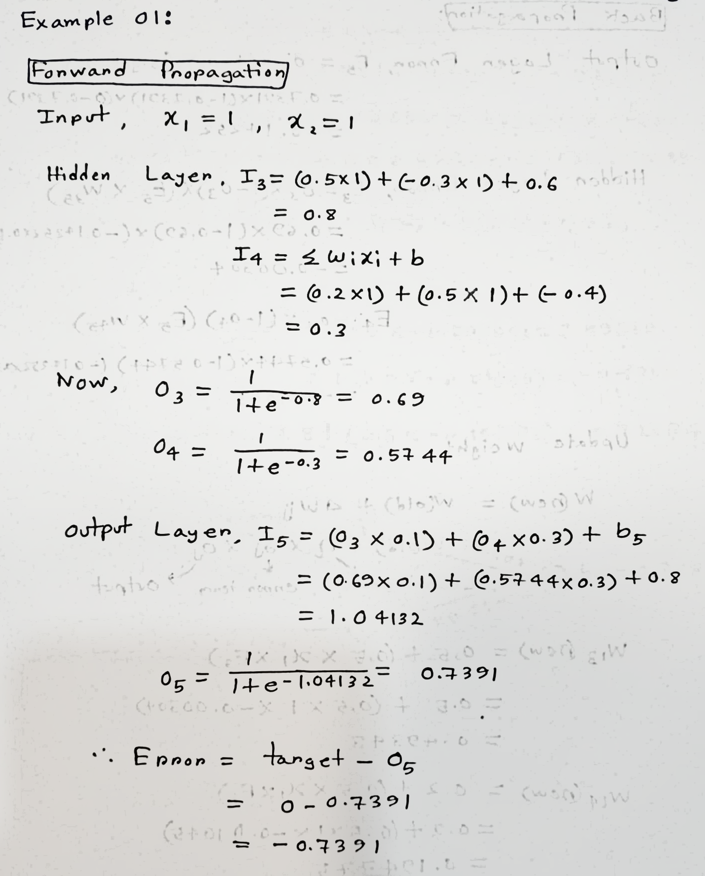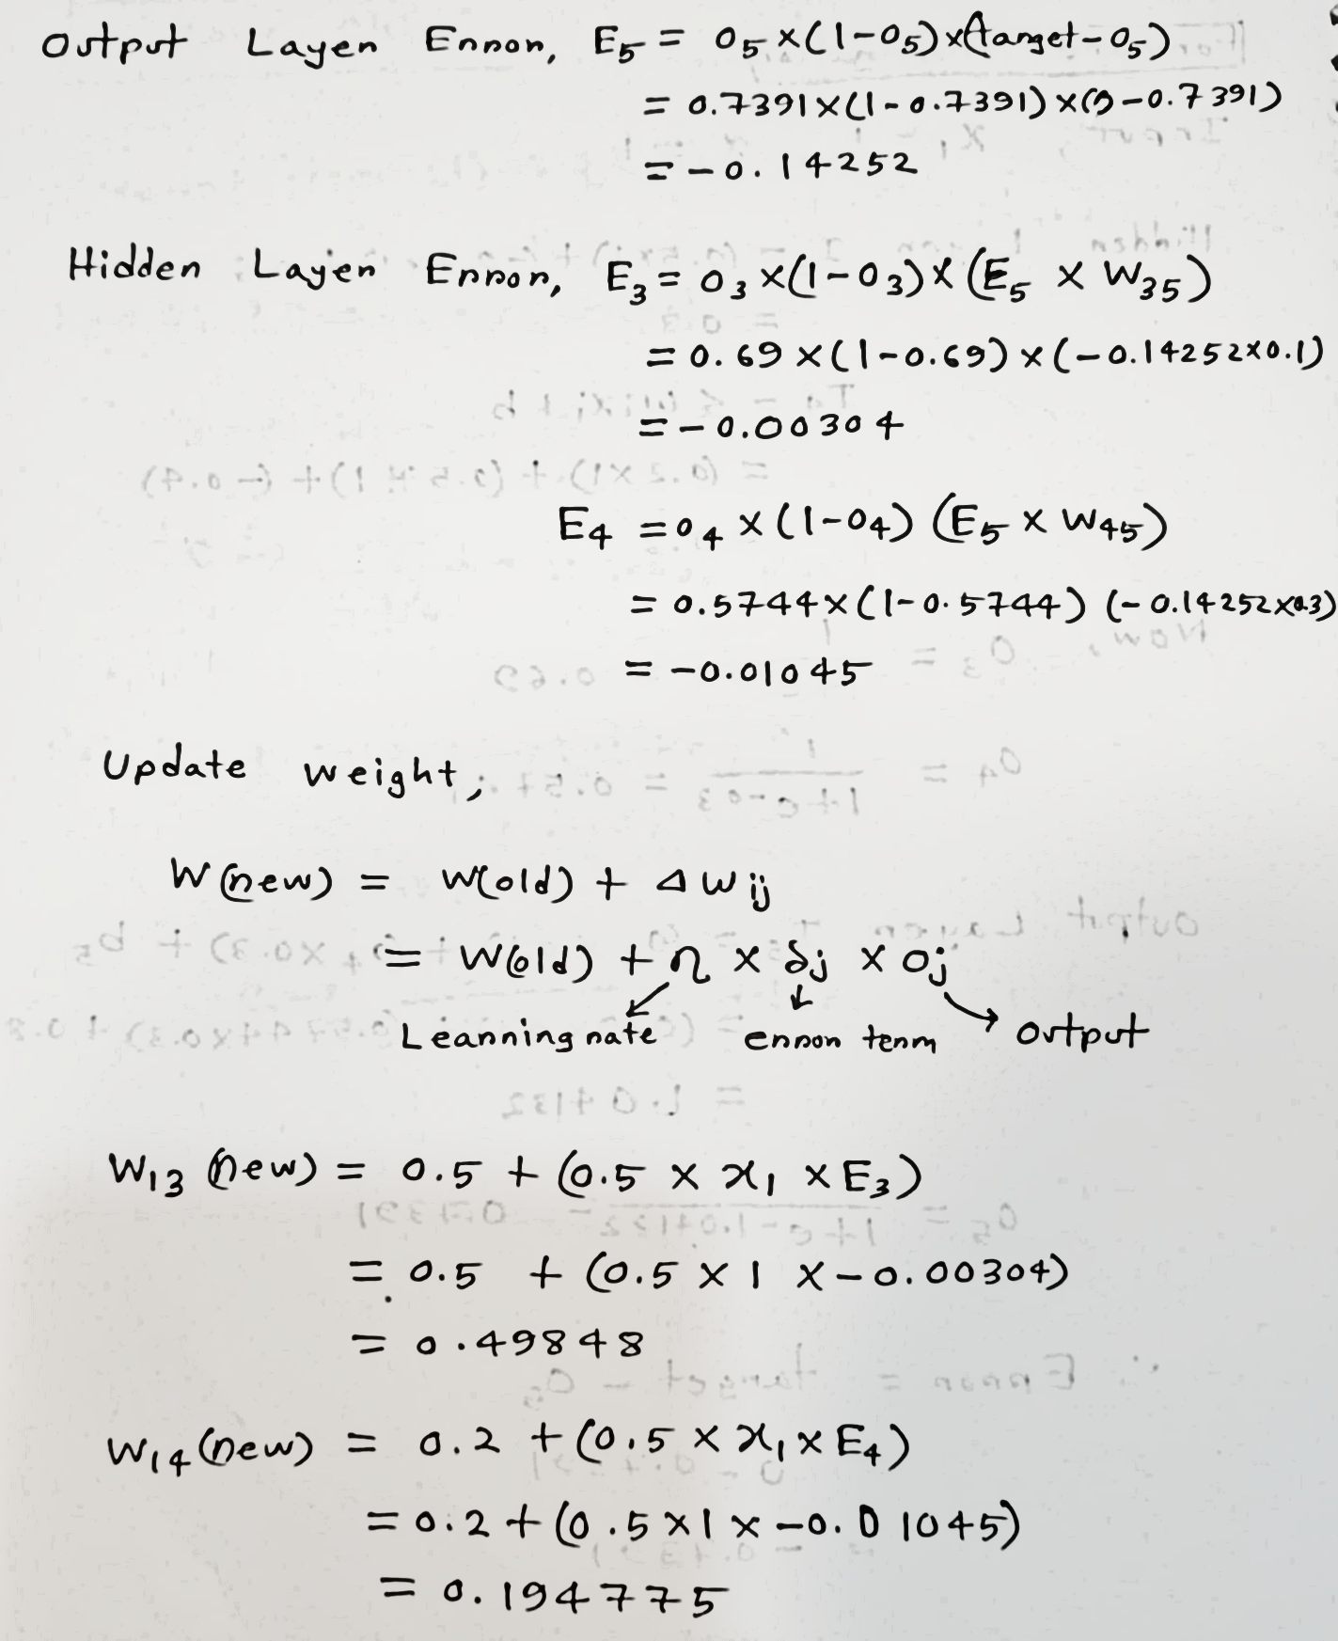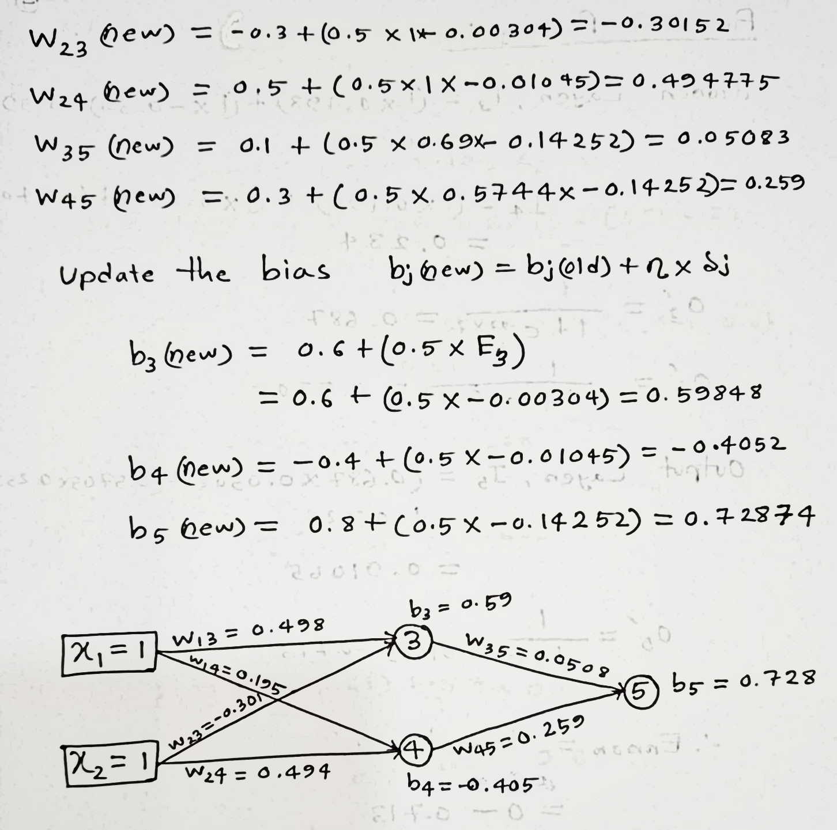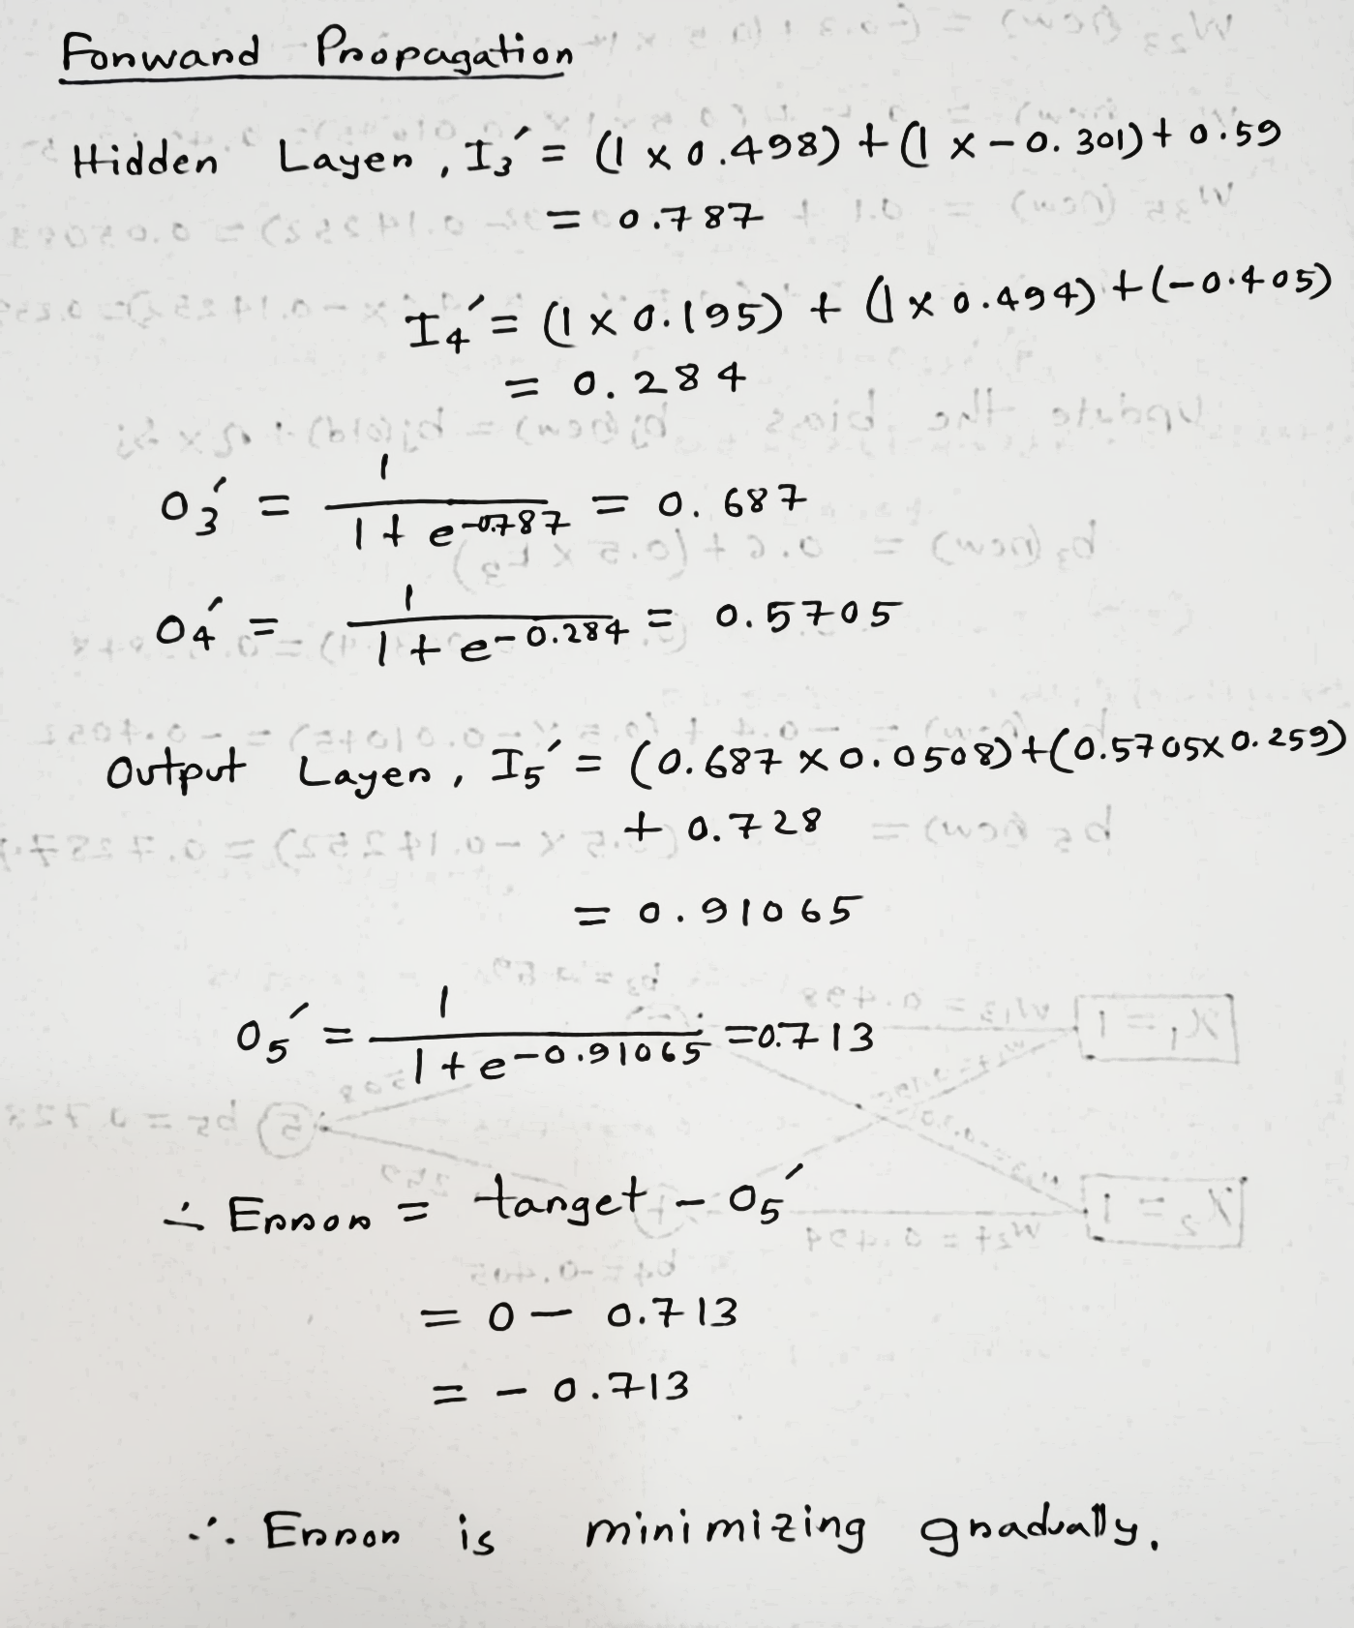

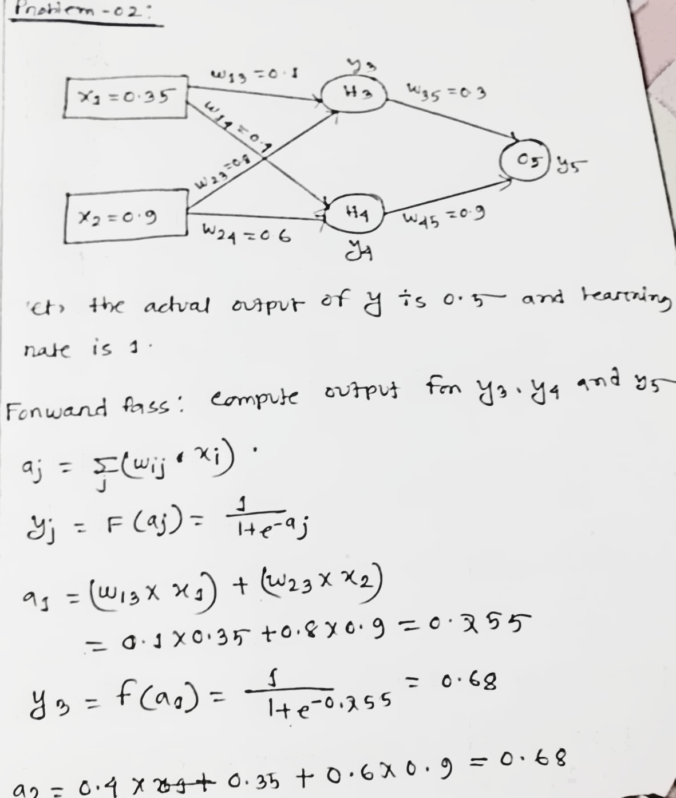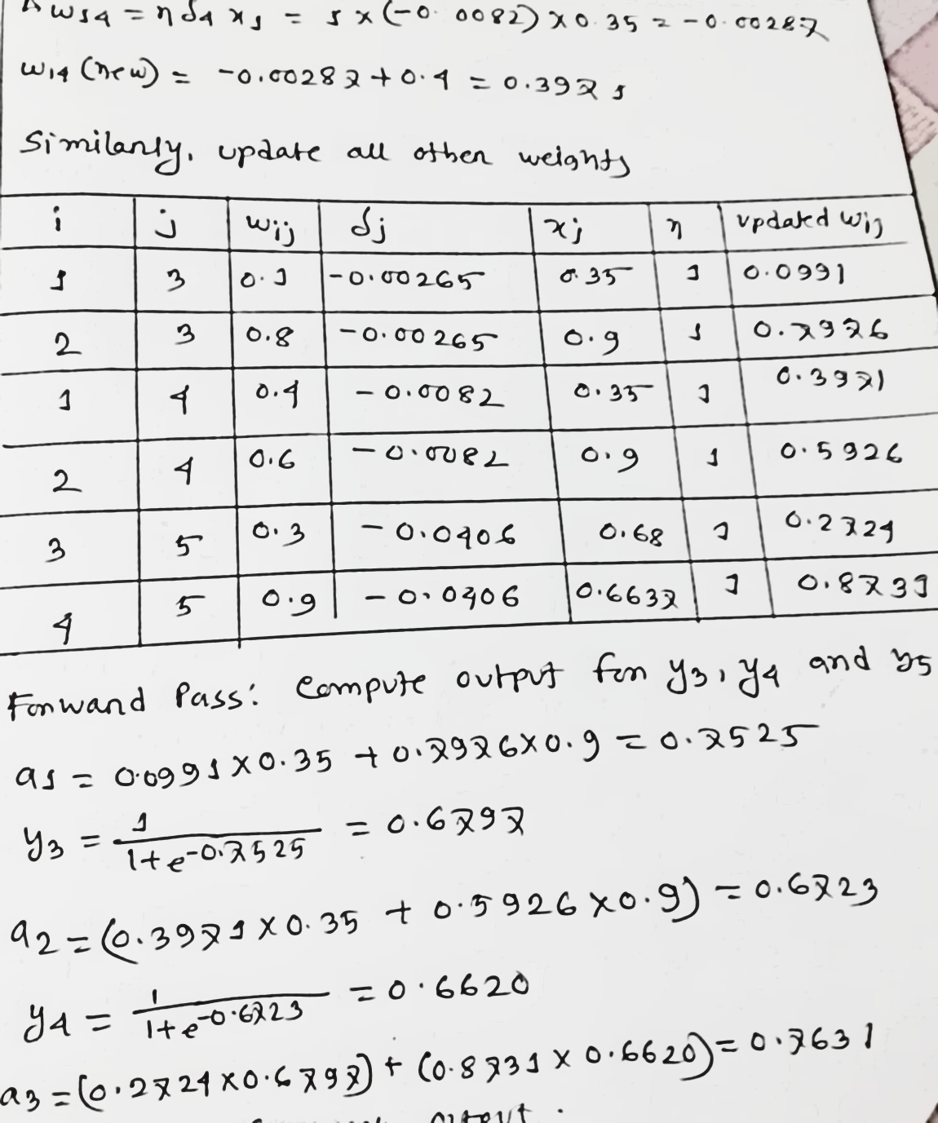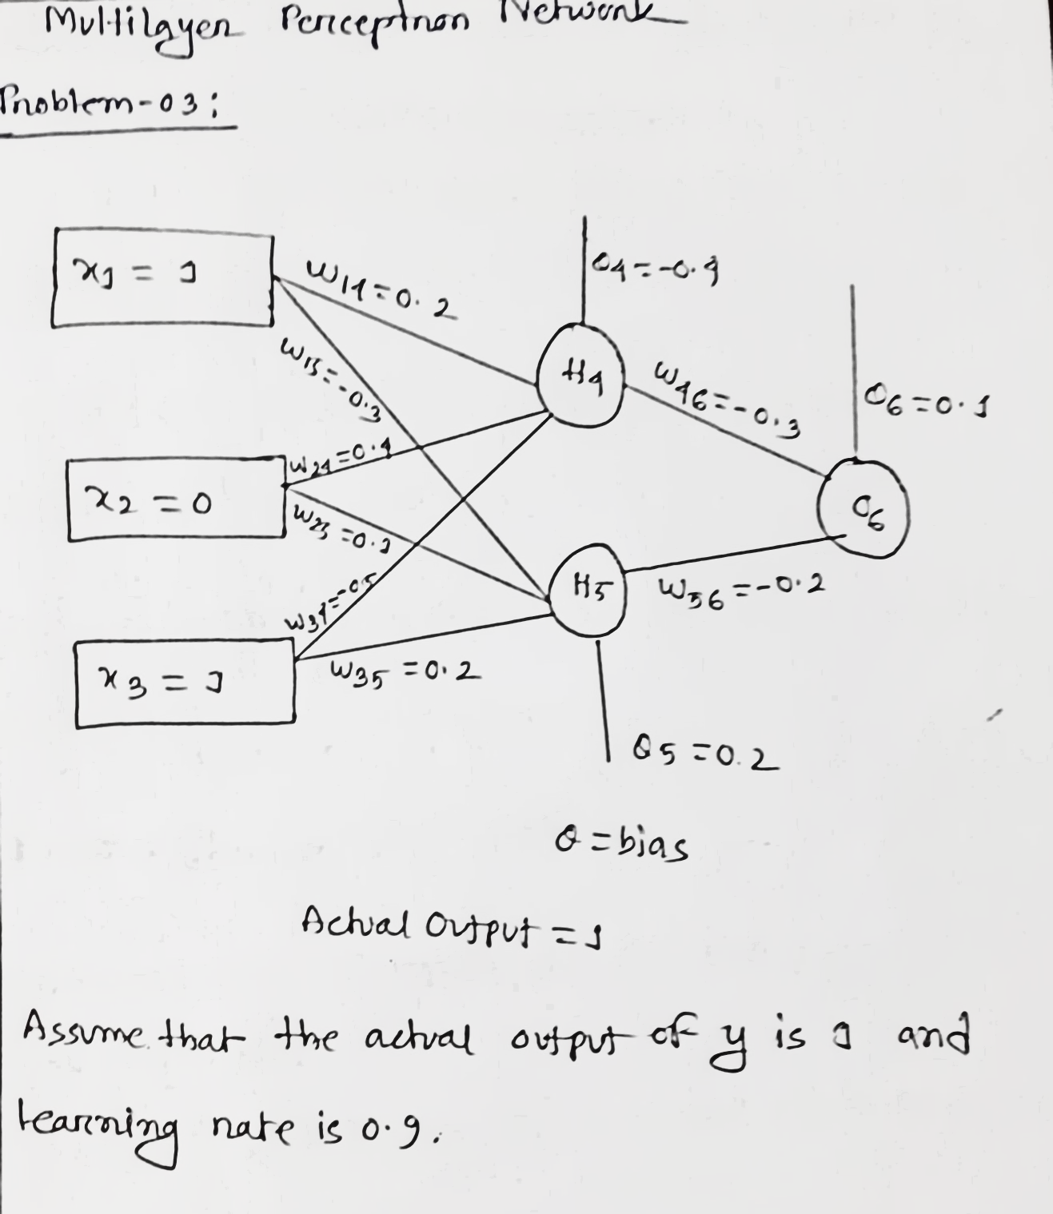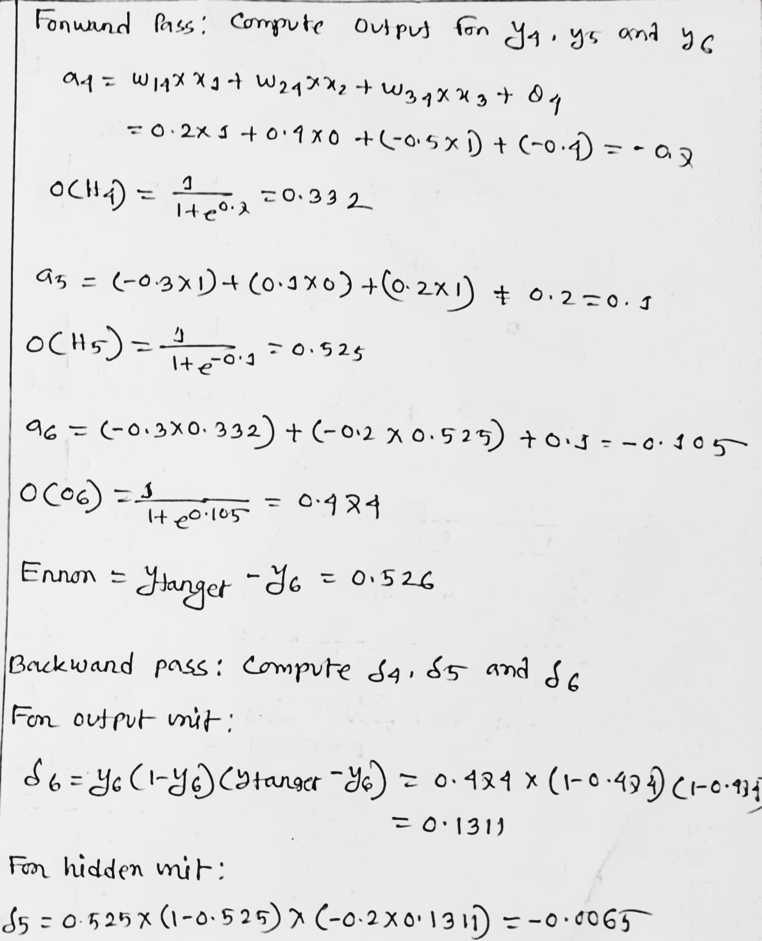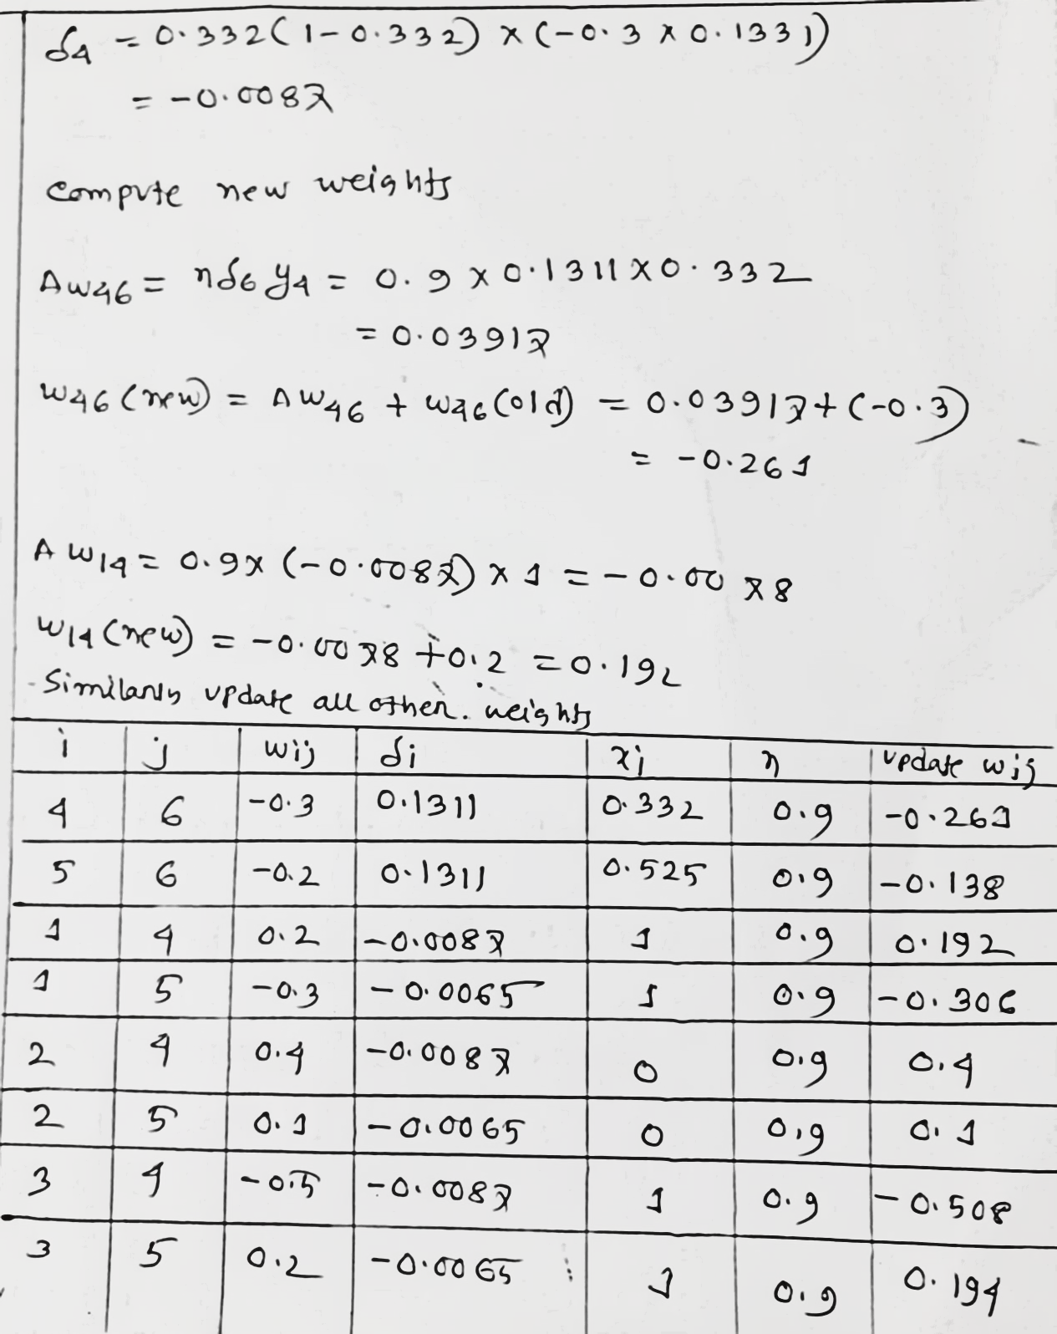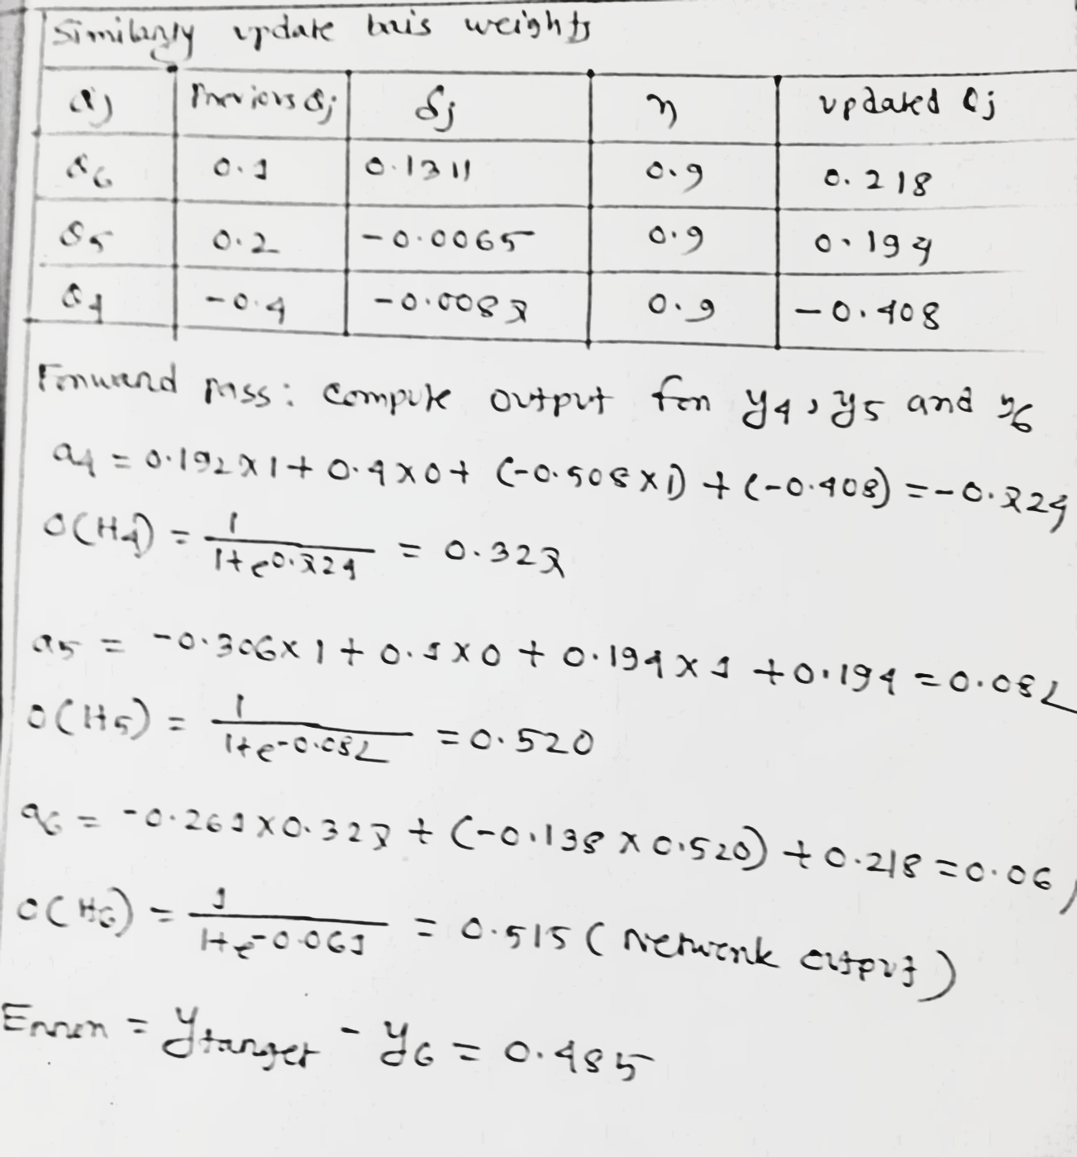

THE END